Order Of Service

Singing: Psalm 119b—CW page 110

Reading: Psalm 119:105-112

Opening Hymn: TLH 648

Reading: Romans 7:7-12

Request Hymn: CW Supplement 750

Reading: Matthew 17:14-21

Sermon Hymn: TLH 236

Sermon Text: Luke 1:1-4

Those Things Believed Among Us

Prayer

The Apostles’ Creed, TLH page 12

Holy Communion

The Lord's Prayer

The Blessing

Closing Hymn: TLH 285

* * * * * * * * * * *
Bible Study: Lambs: Turtle
Sheep: Proverbs 25:11-15
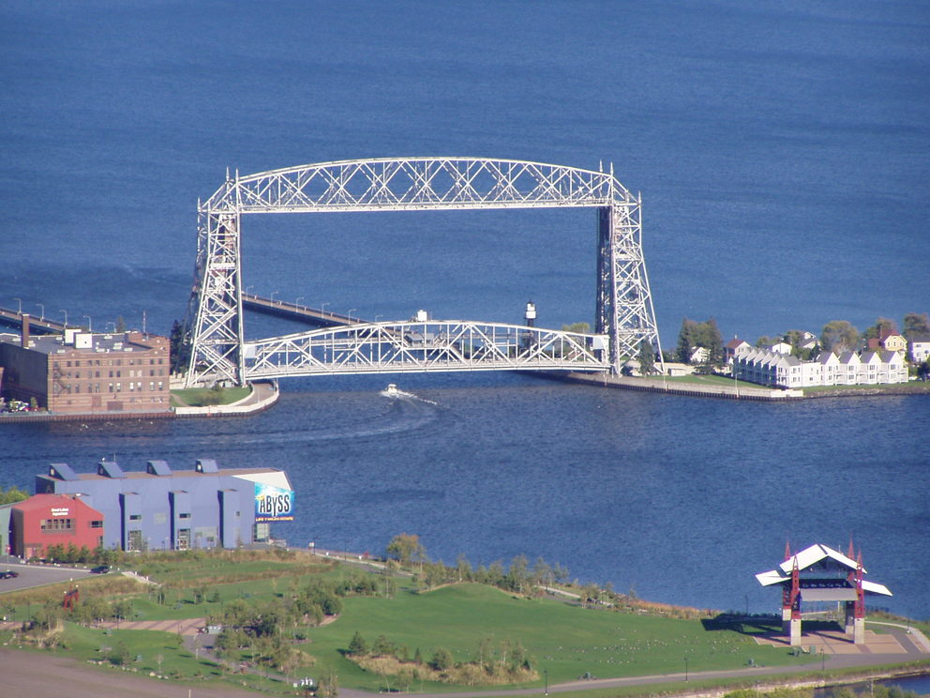

Duluth Rising Bridge

Water
Of
Life

16 August 2020

W A T E R O F L I F E

Independent Christian Church—Conservative Lutheran Doctrine

Worship Service: 9:30 a.m. Bible Study: 10:45 a.m.

Larry Cooper, Pastor E-Mail address:
111 N. Ridge Road lcooper@wateroflife.cc
Coon Valley, WI 54623 Web Site:
www.wateroflife.cc

* * * * * * * * * * * * * * * * * * * * * * * * * * *

Sermon Text: Luke 1:1-4

Those Things Believed Among Us

* * * * * * * * * * * * * * * * * * * * * * * * * * *

Luke 1:1 Forasmuch as many have taken in hand to set forth in order a declaration of those things which are most surely believed among us,
:2 Even as they delivered them unto us, which from the beginning were eyewitnesses, and ministers of the word;
:3 It seemed good to me also, having had perfect understanding of all things from the very first, to write unto thee in order, most excellent Theophilus,
:4 That thou mightest know the certainty of those things, wherein thou hast been instructed.

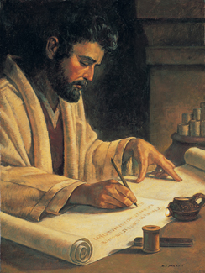

2 Timothy 3:16 All scripture is given by inspiration of God, and is profitable for doctrine, for reproof, for correction, for instruction in righteousness:
:17 That the man of God may be perfect, throughly furnished unto all good works.

